1. Text

   Description automatically generated
2. 
3. We already learnt in the last lecture that followers will continuously request for the msgs from the Leader Brokers to stay in sync with the leaders.
4. 
5. The method of copying msgs at the followers appears full-proof.
6. However, some followers may fail to stay in sync with leaders for various reasons.
7. Two common reasons are:
   1. **Network congestion**: May slow down the replication and so followers may start falling behind.
   2. **Follower Broker crashes/Restart**: When a follower broker crashes, all replicas on that broker will falling behind until we restart the follower broker, they (replicas) will start replicating again.
8. Since the replicas may be falling behind, the leader has one more important list of **I**n-**S**ync-**R**eplicas (ISR).
9. This list is known as the **ISR list of the partition** & **persisted in the Zookeeper and this list is maintained by the leader broker**.  
   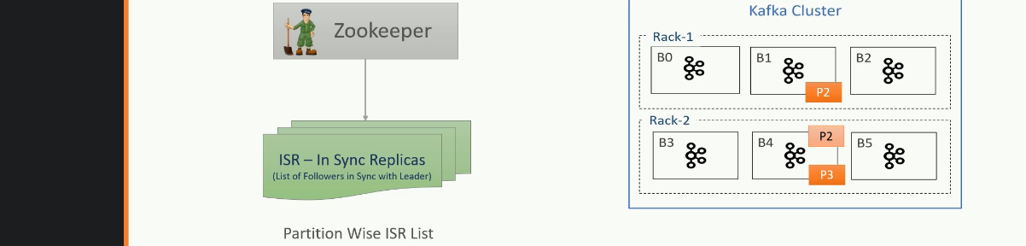  
   The ISR list is very critical. **Why?**Because all the followers in that list are known to be in sync with the leader & they are excellent candidate to be elected as a new leader when something wrong happens to the current leader. That is why ISR is critical.
10. However, there is one question that follows.  
    How does the leader know if the followers are in sync or they are lagging?
11. Let’s try to understand that.
12. The follower will connect to the leader.  
    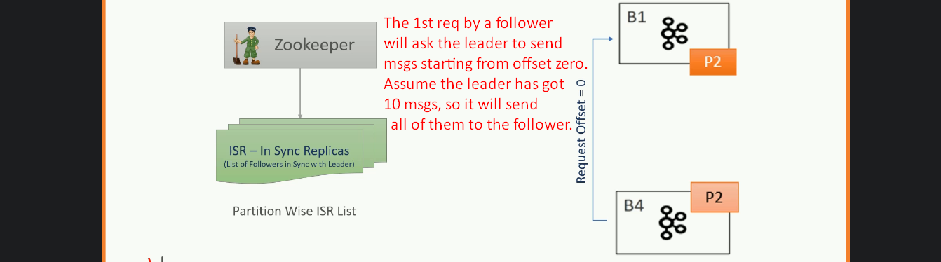
13. Text

    Description automatically generated with low confidence  
    Now the follower again makes the request for the msgs with offset 10.  
    When leader receives the request with the offset 10, the leader can safely assume that the follower has already persisted all the earlier msgs.  
    So, by looking at the last offset requested by the follower, the leader can tell how far behind is the replica.  
    Now the ISR (In-Sync-Replicas) list is easy to maintain. How read next.  
    Chart

    Description automatically generated with medium confidence
14. However, there is a catch here?  
    How do we define the “**Not too Far**” as shown in the above diagram?
15. As a matter of fact, a follower will be always a little behind the leader and that is obvious because follower needs to ask for the msg from the leader, store them in the replica and ask for more.  
    All of these activities take some time and hence, the leader gives them some minimum time as a margin to accomplish this.  
    That is where the notation of “**Not too Far**” arrives.
16. The default value for “**Not too Far**” is 10 seconds.
17. But we can increase/decrease it using kafka configurations.
18. So, a replica can be kept in the ISR list if it is not more than 10 sec behind the leader.  
    That means if a replica (A broker with partition replica) has requested the most recent message in the last 10 seconds, they deserve to be in the ISR.  
    If not, the Leader removes the replica from the ISR (**I**n-**S**ync-**R**eplica).
19. Diagram

    Description automatically generated